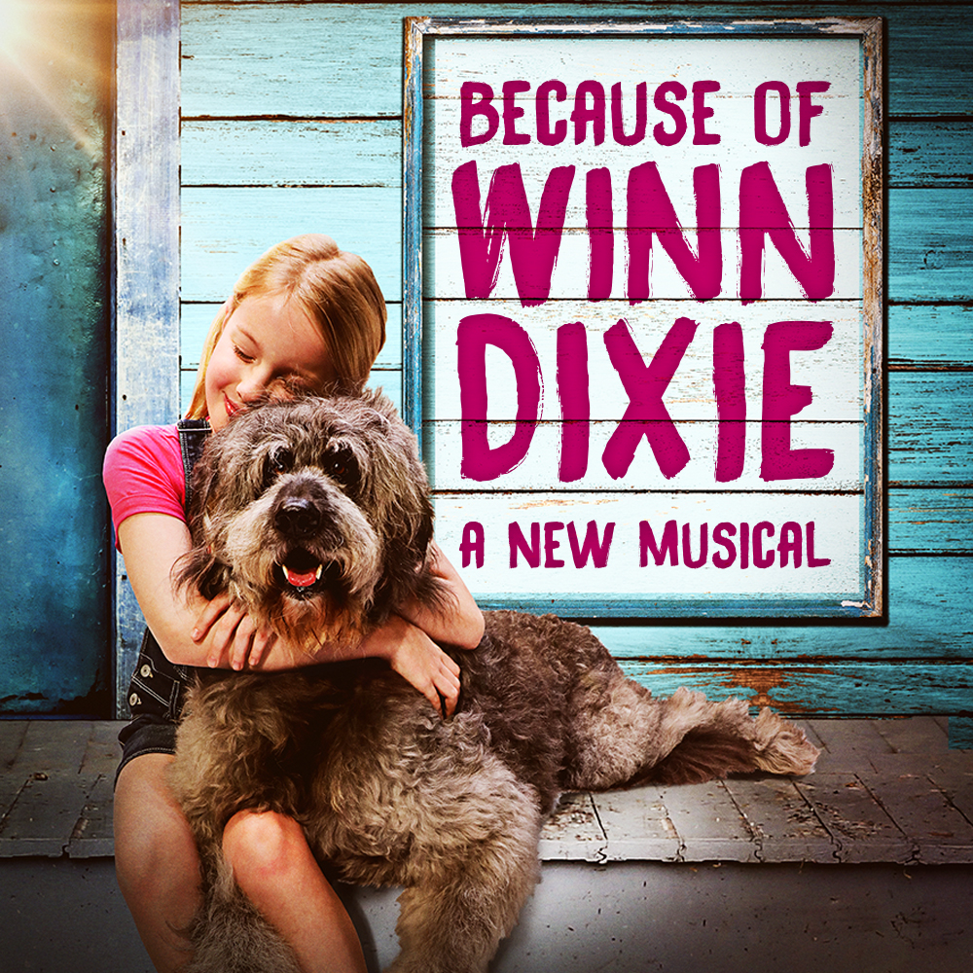­­­

**GOODSPEED MUSICALS PRESENTS**

***Fill in your group’s information below and print on legal size paper.***

**Your Organization Name**

**Performance Date, 00:00 PM**

$00.00

***Event Details:***

Not since *Annie* has a stray dog inspired such joyful noise! In a Southern town filled with lost souls, a new leash on life is just around the corner when a preacher and his daughter take in a mutt named Winn Dixie. The beloved, award-winning novel about a quirky community learning to get along now sings for the first time in this uplifting new musical. Let Grammy and Tony winner Duncan Sheik (*Spring Awakening)*and Tony nominee Nell Benjamin (*Legally Blonde, Mean Girls*) take you on a heartwarming adventure for all ages.

*Your Contact Info*